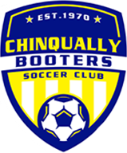 Chinqually is Player First!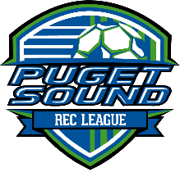
Chinqually Booters is excited to announce we have committed to the Puget Sound Recreational League (PSRL) for Fall 2017 and beyond! We will be joining seven other clubs in the South Puget Sound Area to create a 200-team strong league opportunity for all recreational teams within Chinqually!
The PSRL was established under US Club Soccer with the intention of creating easier access to like-competition teams that helps to foster an atmosphere for happier soccer players! Chinqually will be using this opportunity to focus on building stronger soccer skills, emphasizing more coaching education and promoting passion of the game!

Chinqually along with the PSRL and US Club believe Recreational Soccer is a vital and necessary component of putting all players first! As we continue to evolve, look for more exciting opportunities from Chinqually and US Club as we remain committed to making all players better - and keeping costs low!
League Format
- U9-U10 play 7v7**
- U11-U12 play 9v9
- U13-U19 play 11v11
Division Format
- U10, U11, U12,
- U14, U16, U19
- Boys & Girls
Season
- 10 Games (a minimum of 5 home games)
- League kicks off Sept. 9.
Participating Clubs
- Sumner Soccer Club
- Puyallup
- Franklin-Pierce Rec
- SGEO Fusion
- Cascade Foothills
- Mt. Rainier FC
- Fife, Milton, Edgewood, FME
League Boundaries
- East and south Pierce Counties - from Maple Valley in the north to Sumner and Puyallup to the east and Tacoma to Lacey in the south.

**Our Super Mod program will not be changing formats. Additionally, U8-10 teams will remain a Lacey-only based league when participation levels allow.

